|  |  |  |
| --- | --- | --- |
| **LAB 321Assignment** | **Type:** | **ShortAssignment** |
| **Code:** | **J3.L.P0068** |
| **LOC:** | **250** |
| **Slot(s):** | **10** |

**Title:** Combo Management

**Background**

Restaurant provide services that customer can order a party online. The restaurant also has promotion programs

**Program Specifications**

Program a web site display list of combo and a page that allow a user to add new a combo, update combo details, and add a dish to combo

**Features:**

This website contains following main functions

* Function 1: List Combo
  + The list of combo will be displayed
  + The combo list must be paging
* Function 2: Add New Combo
* Function 3: Update Combo Details
* Function 4: Add Dish to Combo

Database description

* Database must contain combo, dish detail information displayed on the screen

***Expectation of User interface:***

**PIC 1: Combo List** 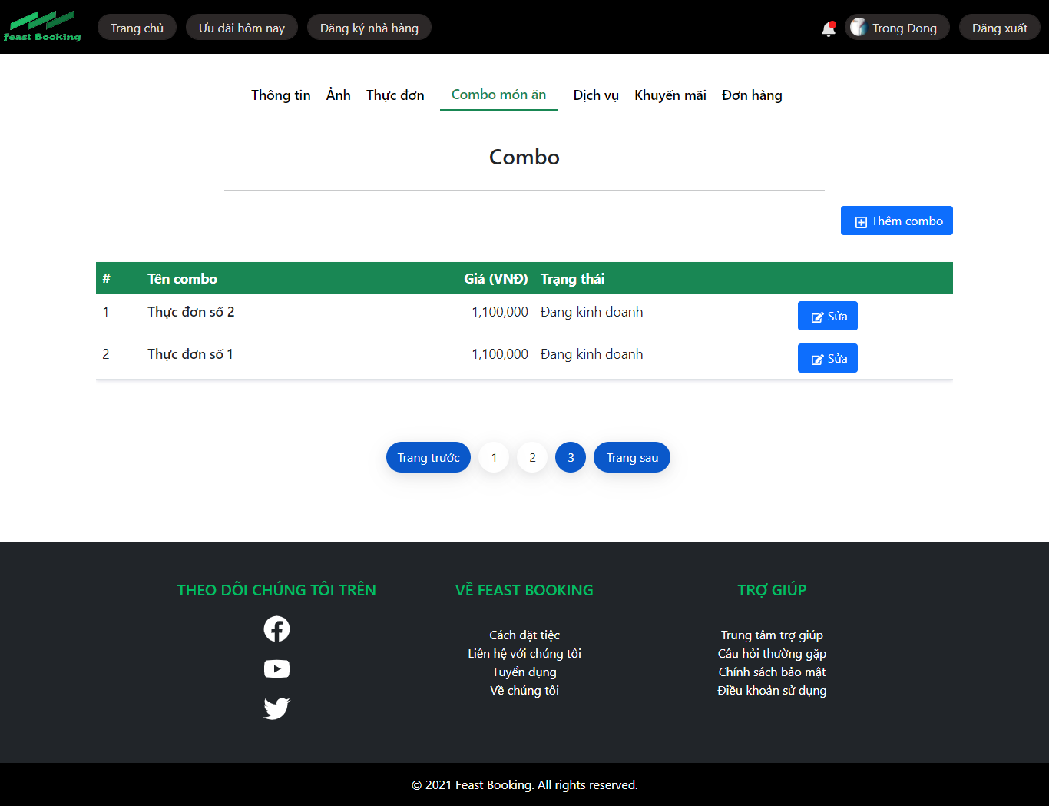

**Note: The following fields must be displayed**

1. Combo Name
2. Combo Value
3. Status
4. Previous/Next button
5. Edit button : When user click on “Edit” button, the system will display the Edit **Combo** like page as P**IC03**
6. Add Combo button: When the user click on “Add Combo” button the system will display the Add Combo **Dish** page as P**IC02**

**PIC 2: Add Combo**

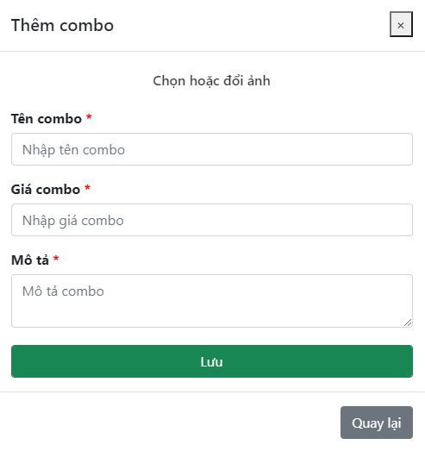

**Note: The following fields must be displayed**

1. All fields in the screen must be got from database
2. When user click on “Back”, the dishes list will be displayed
3. When user click on “Save”, the dishes list will be displayed

**PIC 3: Update Combo**

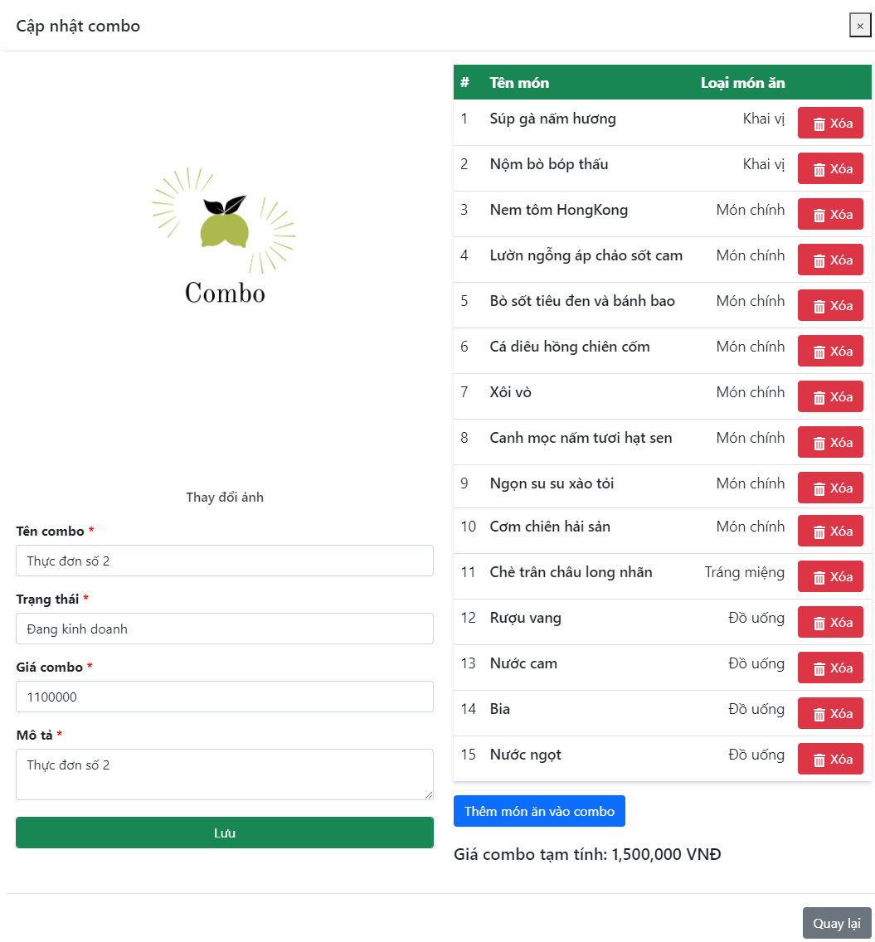

**PIC 3: Add Dish to Combo**

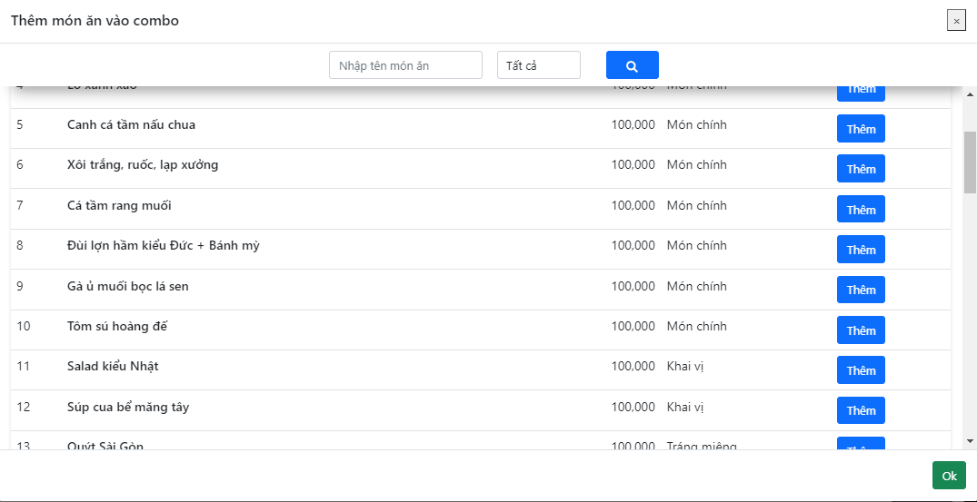

**Guidelines**

* Step 1 : Create web layout
* Step 2 : Create prototype
* Step 3 : Design database base on created prototype
* Step 4 : Code & Test